Data Disk Storage, Backup and Recovery

Samantha Krall

SYM-400

Database tables and indexes may be stored on disk in one of several forms, including ordered/ unordered flat files, ISAM, heap files, hash buckets or B+ trees. Each form has its own advantages and disadvantages. The most commonly used forms are B+ trees and ISAM. Such forms or structures are one aspect of the overall schema used by a database engine to store information. Unordered storage typically stores records in the order they are inserted. Such storage offers good insertion efficiency O(1) but inefficient retrieval times O(n). Ordered storage typically stores the records in order and may have to rearrange the file size when a new record is inserted, resulting in lower insertion efficiency. However, ordered storage provides more efficient retrieval as the records are pre-sorted, resulting in a complexity of O(log n). Heap files are lists of unordered records of variable size. Some of its advantages are efficient for bulk loading data, for relatively small relations as indexing overheads are avoided and when retrievals involve large proportion of stored records. Some disadvantages are that it is not efficient for selective retrieval using key values, sorting may be time consuming and it is not suitable for volatile tables. B+ trees are the most commonly used in practice. Time taken to access any record is the same because the same number of nodes is searched, and the index is a full index, so the data file does not have to be ordered.

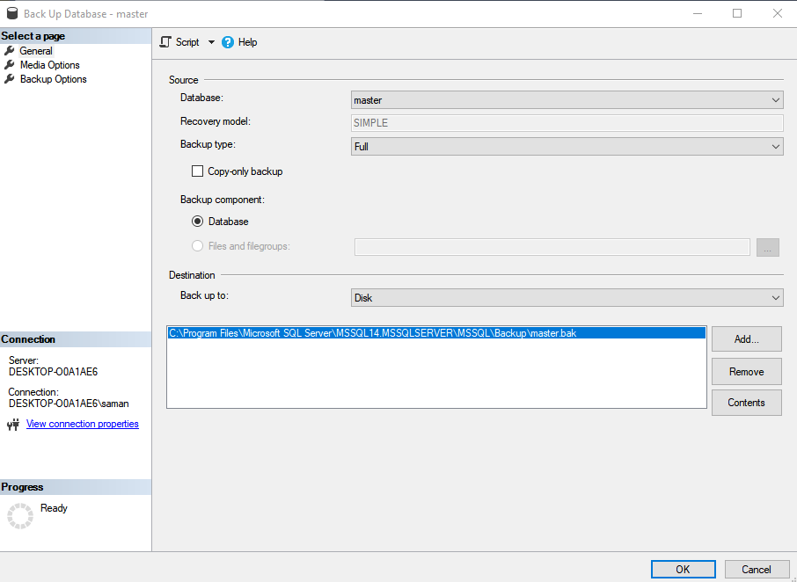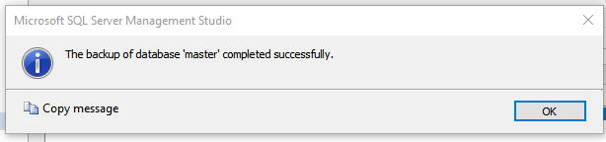

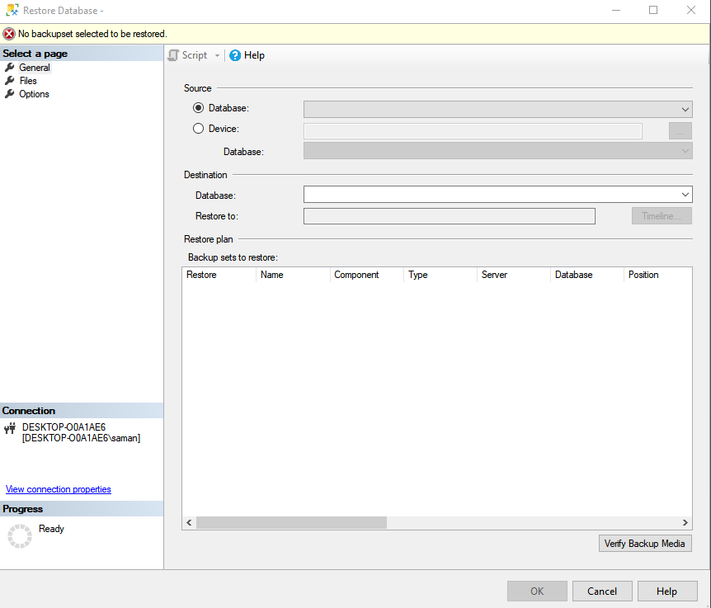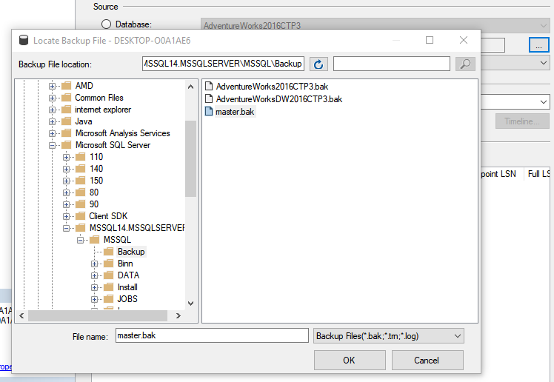

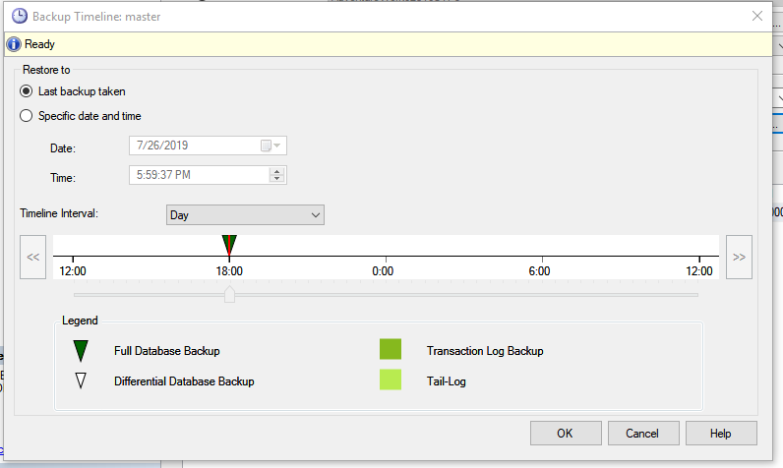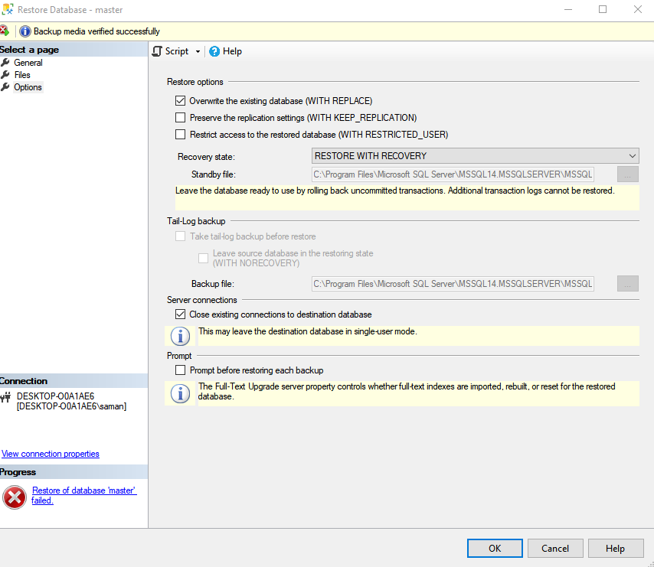

References:

<https://en.wikipedia.org/wiki/Database_storage_structures>

<https://docs.microsoft.com/en-us/sql/relational-databases/backup-restore/back-up-and-restore-of-sql-server-databases?view=sql-server-2017>

<https://docs.microsoft.com/en-us/sql/relational-databases/backup-restore/create-a-full-database-backup-sql-server?view=sql-server-2017>

<https://docs.microsoft.com/en-us/sql/relational-databases/backup-restore/restore-a-database-backup-using-ssms?view=sql-server-2017>